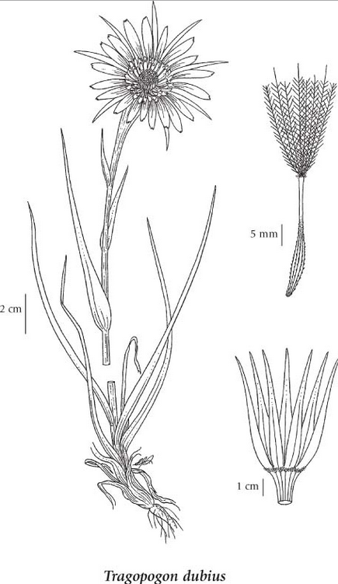
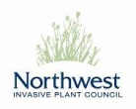
Tragopogon Identfication And Control

Common Name(s): Western Goat’s beard or Yellow salsify
Scientific Name: Tragopogon dubius Scop.
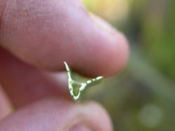
Legal Status: Exotic with a low extant.
*There are significant inventory gaps.
Invasiveness: High Threat: Low
General:
Biennial or sometimes annual herb from a taproot; stems erect, solitary, simple or sometimes branching from the base, lightly woolly-hairy when young, becoming glabrous except at leaf bases, exuding milky juice when broken, 0.3-1 m tall. Cross section of plant stem is triangular.
Flowers:
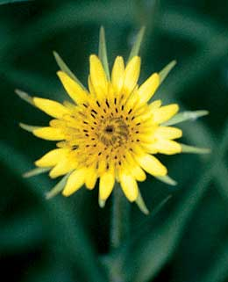
Heads with strap-shaped flowers, solitary, on much-enlarged, hollow stalks terminating the stems or few branches; involucres 2.5-7 cm tall; involucral bracts linear-lanceolate, equal, usually about 13 or only 8 on dwarfed plants or on last-formed heads, distinctly surpassing the ray flowers; ray flowers pale yellow.
Leaves:
Basal leaves lacking; stem leaves entire, grasslike, tapering uniformly from base to the apex, parallel-veined, with clasping bases, 20-50 cm long, 0.5-2 cm wide.
Fruits:
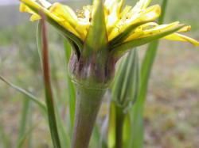
Heads with strap-shaped flowers, solitary, on much-enlarged, hollow stalks terminating the stems or few branches; involucres 2.5-7 cm tall; involucral bracts linear-lanceolate, equal, usually about 13, distinctly surpassing the ray flowers; ray flowers pale yellow; disk flowers lacking.
Control: Most effective control is chemical as mowing will not eradicate the plant.
Chemical: A combination of 2, 4-D and dicamba applied during the rosette stage provides effective control and helps to increase perennial grasses.

For more information on invasive plant species visit www.nwipc.org
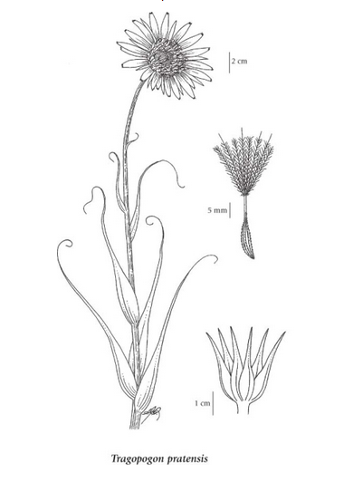
Common Name(s): Meadow Goat’s beard or Meadow Salsify
Scientific Name: Tragopogon pratensis L.
Legal Status: Exotic with a low extant.
*There are significant inventory gaps.
Invasiveness: High Threat: Low
General:
Biennial herb from a taproot; stems erect, solitary, simple or more commonly branching from the base, lightly woolly-hairy when young, becoming glabrous except at leaf bases, exuding milky juice when broken, 15-80 cm tall.
Leaves:
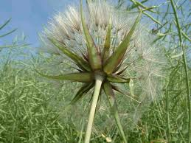
Basal leaves lacking; stem leaves entire, grasslike, becoming broader just above the base then tapering uniformly to the apex, parallel-veined with clasping bases, 5-30 cm long, 0.5-2 cm wide.
Flowers:
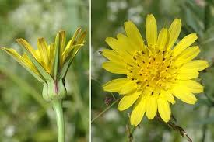
Heads with strap-shaped flowers, solitary, on straight, hollow stalks terminating the stems or few branches; involucres 1.2-2.4 cm tall; involucral bracts lanceolate, swollen at the base, equal, 5-11 or more commonly about 8, equalling or shorter than the ray flowers; ray flowers bright yellow; disk flowers lacking.
Fruits:
Achenes elongate, 5- to 10-ribbed, 1.2-2.4 cm long, abruptly tapering to the slender beak; pappus of whitish, slender tipped, feathery bristles, the feather branches interwebbed.
Control: Most effective control is chemical as mowing will not eradicate the plant.

Chemical: A combination of 2, 4-D and dicamba applied during the rosette stage provides effective control and helps to increase perennial grasses.
Important Note*** Herbicide recommendations and use must consider site characteristics and be prescribed based on site goals and objectives. Herbicide labels and other sources of information must be reviewed before selecting and applying herbicides.
• Ensure that chemical treatments do not injure or kill susceptible, non-target vegetation.
• The following herbicides provide effective control for common tansy: picloram, picloram/2,4 D, metsulfuron methyl, and aminopyralid.
• Application of pesticides on Crown land must be carried out following a confirmed Pest Management Plan
(Integrated Pest Management Act) and under the supervision of a certified pesticide applicator:www.env.gov.bc.ca/epd/ipmp/

